
Business Question and Visualization Report

Date | 27 October 2026
Team ID | Not provided by user
Project Name | Global Olympic Sports Performance Analysis
Maximum Marks | 5 Marks

Visualization development refers to the process of creating graphical representations of data to facilitate understanding, analysis, and decision-making. The goal is to transform complex datasets into visual formats that are easy to interpret, enabling users to gain insights and make informed decisions. Visualization development involves selecting appropriate visual elements, designing layouts, and using interactive features to enhance the user experience. This process is commonly associated with data visualization tools and platforms, and it plays a crucial role in business intelligence, analytics, and reporting
Business Questions and Visualisation
The process involves defining specific business questions to guide the creation of meaningful and actionable visualizations in Tableau. Well-framed questions help in identifying key metrics, selecting relevant data, and building visualisation that provide insights.

Project-Specific Business Questions and Visualizations
1. Which sport categories have the highest average medals per athlete?
Visualization: Bar chart: average Total Medals by Sport Category. Compare categories using the same aggregation and note the dataset scope.
Observed workbook element: “Avg Medals per Athlete by Category”. Validate the source field definition before stating a highest/lowest category.
2. Which countries lead the dataset by total Olympic medals?
Visualization: Ranked horizontal bar chart: Country by SUM(Total Medals), with Overall Rank as a comparison field.
Observed workbook element: “Global Performance by Country”. Use the plotted order and source ranking; verify country names and sort direction in Tableau.
3. How does the total number of medals awarded change over Olympic years?
Visualization: Line chart: Year versus SUM(Total Medals Awarded). Inspect turning points without assuming event counts are constant.
Observed workbook element: “Trend of Total Medals Awarded”. Differences may reflect event counts and dataset coverage as well as performance.
4. How does the investment score relate to total medal output?
Visualization: Scatter plot: AVG(Investment Score) versus SUM(Total Medals), with Country as the mark label. Treat patterns as association, not causation.
Observed workbook element: “Sports Investment vs Medal Performance”. A scatter plot shows association only; it does not establish causal impact.
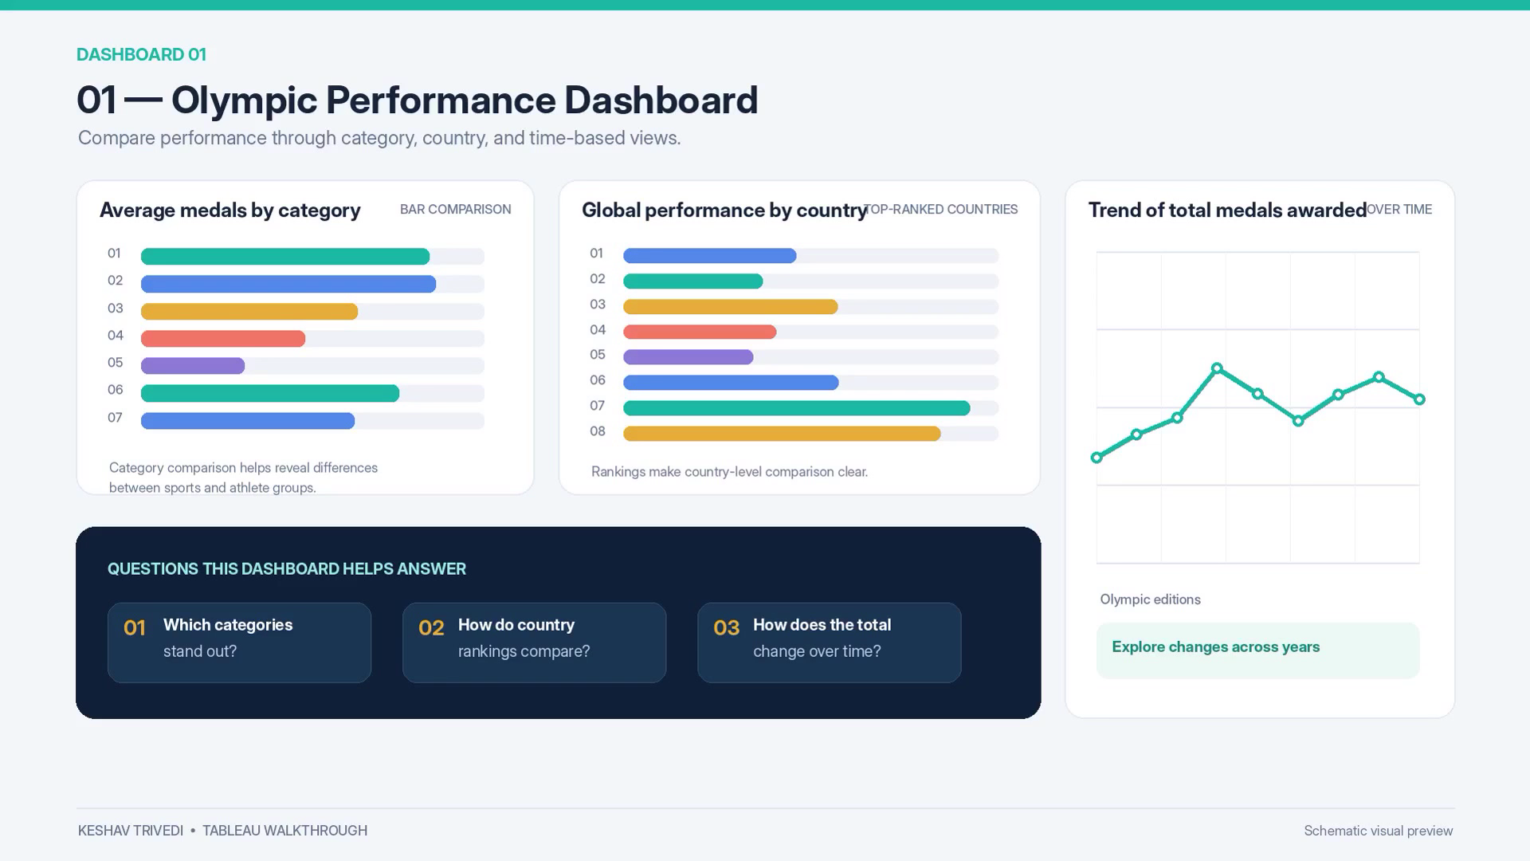
Figure 1. Olympic Performance Dashboard screenshot from the supplied walkthrough video.
5. Which regions have higher average medal-efficiency values?
Visualization: Bar chart: Region versus AVG(Medal Efficiency Pct). Confirm the field definition and scale before making conclusions.
Observed workbook element: “Avg Medal Efficiency by Region”. Confirm how efficiency was defined and whether regional samples are comparable.
6. How do medal totals compare for countries marked as Olympic hosts?
Visualization: Bar comparison: Country/Host Advantage versus SUM(Total Medals). Do not infer host-caused increases without before/after analysis.
Observed workbook element: “Medals Across Olympic Hosts”. Host status should be treated as context, not proof of a host advantage.
7. How are total medals distributed across the regions in the dataset?
Visualization: Donut chart: Region share of SUM(Total Medals). Verify region labels and totals before reporting percentages.
Observed workbook element: “Medal Distribution by Region”. Confirm percentages and region labels before quoting values.
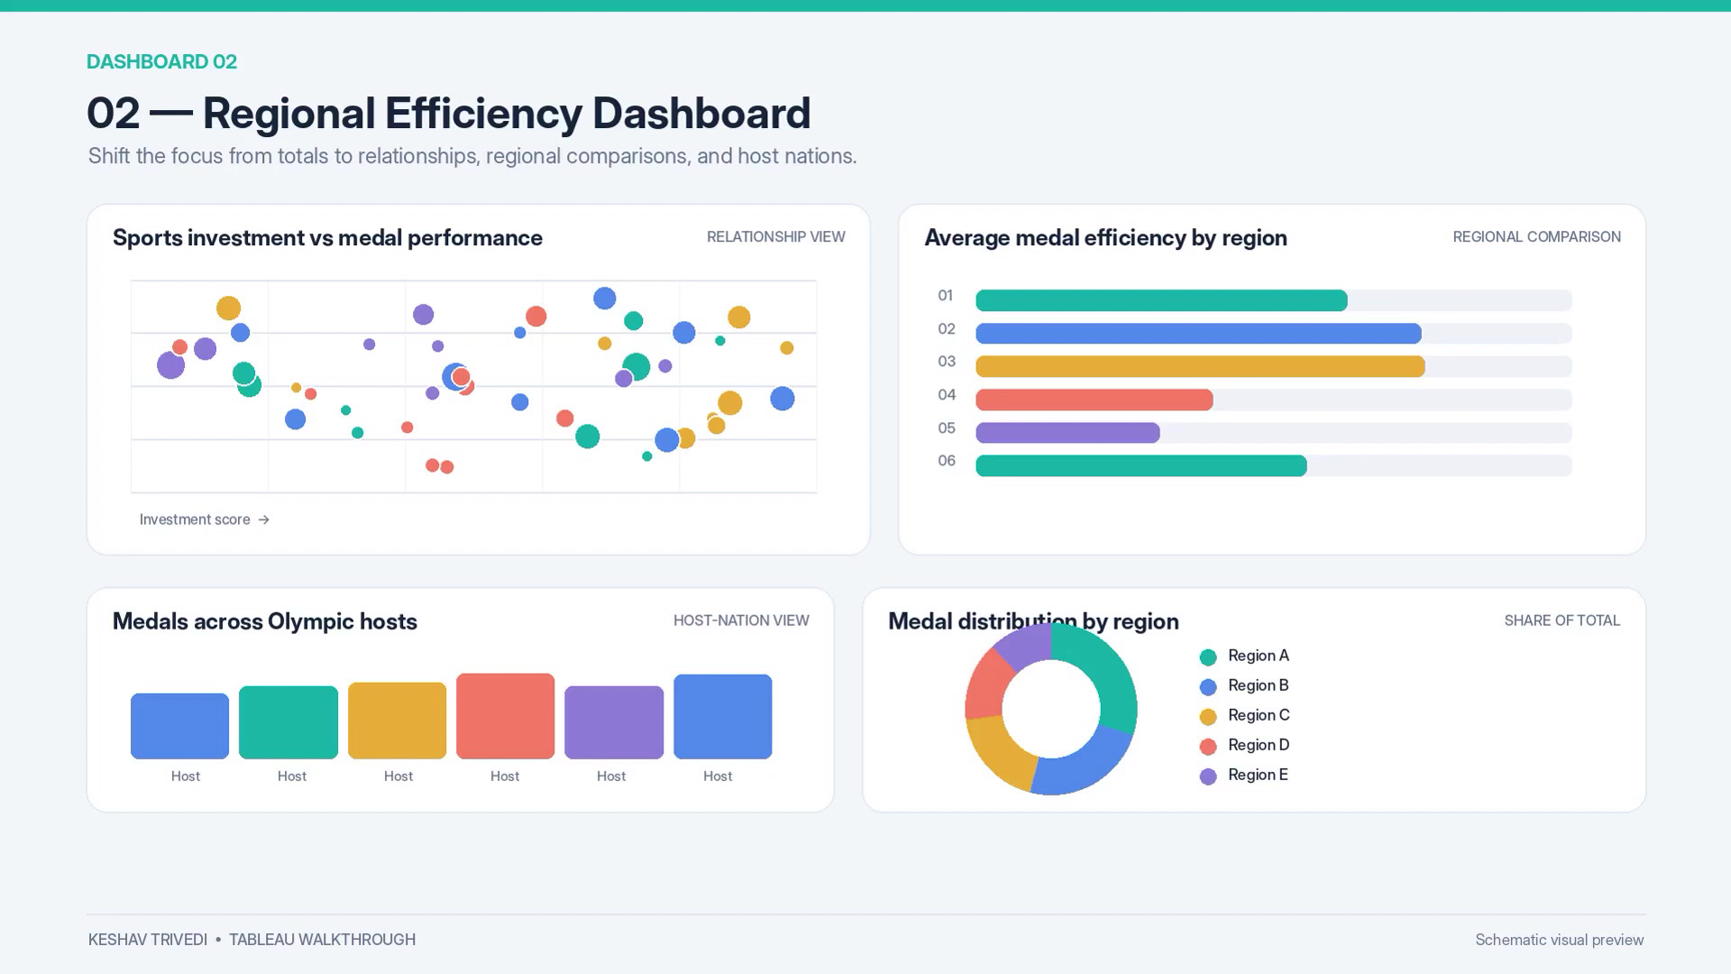
Figure 2. Regional Efficiency Dashboard screenshot from the supplied walkthrough video.
8. Do country rankings and total medal counts tell a consistent story?
Visualization: Combined country comparison: Overall Rank with total medals. Investigate exceptions and confirm ranking direction.
Observed workbook element: Country Rankings extract provides Overall Rank and Total Medals; use it to check whether rank order matches totals.

Data and Evidence Notes
The workbook contains seven worksheets and two dashboards backed by four packaged Hyper extracts. These descriptions are verified from the workbook metadata. Numeric findings should be recorded only after checking the values and tooltips in Tableau; no unsupported medal counts or causal claims are asserted in this report.

